- Purpose
  - The purpose of this document is to describe the procedure for assembling the wheels of an Optima Propane Burnisher.
- Scope
  - This SOP applies to all equipment assembly team members. The process applies to the following machines:
E012800EQM0600BE1200 – 21” Optima XR
E012805EQM0600BE1200 – 21” Optima XR w/ Clutch
E012815EQM0600BE1200 – 21” Optima XR w/ Emissions & Clutch
E012830EQM0600BE1200 – 27” Optima XR
E012835EQM0600BE1200 – 27” Optima XR w/ Clutch
E012840EQM0600BE1200 – 27” Optima XR w/ Emissions
E012850EQM0600BE1200 – 27” Optima XR w/ Dust Control
E012860EQM0600BE1200 – 27” Optima XR w/ Clutch & Dust Control
E012865EQM0600BE1200 – 27” Optima XR w/ Emissions & Dust Control
E012875EQM0600BE1200 – 27” Optima XR w/ Emissions, Clutch, & Dust Control
- Responsibilities
  - The operations manager/supervisor is responsible for enforcing this SOP.
- Materials
  - The proper materials needed for this process are listed on the machine work order.
  - Hand/Power Tools
- Definitions

- Procedure
  - The wheel brackets should be assembled in pairs as they are mirror images of each other. Start with the wheel (12689). Be sure to include a sleeve bearing that is supplied with the wheel but is probably stored separately. This bearing goes inside the ID of the wheel.
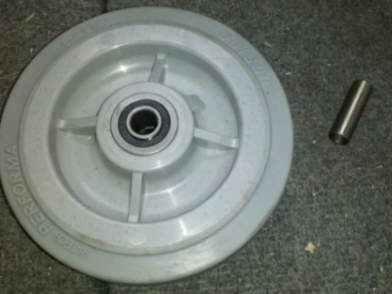

  - Take the wheel, a wheel bracket (86225), a bolt (10902), and a nut (10141) and bolt them all together. On the wheel bracket are two holes. Use the one that is closest to the edge for a 27” machine. Use the other hole for a 21” machine.

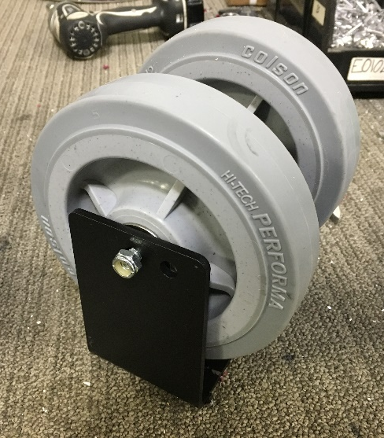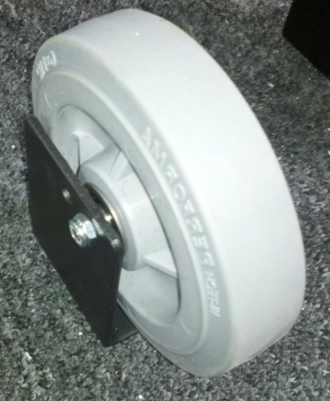
21” machine
27” machine

  - Bolt together the opposite wheel bracket. All is the same except that the bolt should point the opposite direction. The completed assemblies should be mirror images of each other.
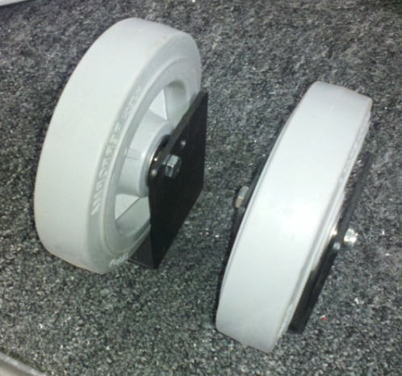

- References (optional section as needed)

- Training Guide

Functional Training Groups Requiring Training
Equipment Assembly Group

- SOP Change Control

Date of Change | Reason for Change
Rev 01 - 11/22/2013 | This is the first version of the S.O.P. hence there are no revisions to this document.
Rev 02 - 1/15/2018 | Added Responsibilities Section
Rev 03 - 5/4/2018 | Updated for the Optima XR upgrades
Rev 04 - 3/21/2025 | Removed work center notes
Rev 05 – 11/17/2025 | Updated applicable machine ID’s in section Scope 2.01

Approvals

Submitter/Author Approval:__________________________________ Date:______________________

Management Approval:______________________________________ Date:______________________

QAU Approval:_____________________________________________ Date:______________________

